2017 Order Form
For Questions, E-mail legislate@nysutmail.org

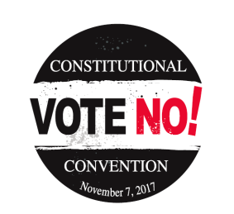  Item | Quantity | Item Price | Total
Button |  | 50₵ | $
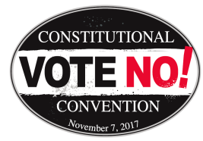  Magnet |  | $1.00 | $
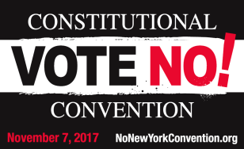  *Lawn Sign |  | $2.00 | $
*Due to the size of the wire stakes, all lawn sign orders will be shipped to NYSUT Regional Offices. You will be
notified by NYSUT’s Regional Office staff when your order is available for pick-up.
Check enclosed. (Make check payable to: NYSUT Advocacy Fund and mail to: NYSUT Legislate and Political Department,
800 Troy-Schenectady Road, Latham, New York 12110) Orders that are not submitted with payment will not be processed.

Please Print
Name:
Local/Organization:
Shipping Address:
City:
State:
ZipCode:
Telephone: | ( ) ---
Email:
Billing Contact:
Billing Address:
City:
State:
ZipCode:
For Office Use Only:

Date Shipped: _____/______/2017 Shipped By: ________
Quantity Shipped: ______________
Sent copy to Accounting for Invoice
Payment Received Check #: __________

44128

nonewyorkconvention.org
43588

